# Global Resources Superstore Sales and Supply Chain Report

# 1. Introduction

This report analyzes the sales and supply chain performance of Global Resources Superstore. The report will provide an in-depth analysis of the supply chain data, examining product sales, transportation cost, customers demographics, shipping carrier performance, product availability and shipping efficiency. Based on the derived insights, tactical recommendations and next steps are provided to improve operational efficiency, implement cost-efficient processes and increase overall profitability of the business.

## Objective of the Project

The project aims to achieve the following objectives:

* Analyze revenue trends to gain meaningful insights that can help improve revenue
* Examine the cost-efficiency of the transportation system, help to optimize the system by reducing expenses
* Determine how the optimization of routes and carrier efficiency affect logistics system for the business
* Identify areas that can help optimize logistics and sales strategies with an overall increase in revenue generation.

## Problem Being Addressed

The analysis would help address the following problem:

* Identifying the most profitable product categories that could lead to the business breaking even.
* Cost-efficient transportation routes, that is reliable and deliver fast at a reasonable low cost
* Revenue -driving shipping carriers to enhance operational capability
* How does Customer demographic alter a favorable sales performance and their retention strategies.
* Investigating the effect of product availability on sales performance.

## Overview of Data and Methodologies

The project is based on the in-depth analysis of sales and supply chain data for Global Resources company. The dataset covered the following areas:

* Revenue generated - Detailing revenue and how each product contributed to this.
* Customers demographic- Spotlight the customer demographics that demonstrated highest purchasing ability
* Product type- Categorized product type to determine the star product and its contribution to overall sales.
* Suppliers’ geographical location-identifying the best supplier that provide value added services at a cost-efficient way
* Shipping carriers and transportation mode-the implication of several modes of transportation on the overall revenue generated.

## Methodologies

The project analysis was carried out using Microsoft Excel together with some of its functions:

* Pivot Tables & Charts -This was applied to conduct data grouping, analysis and visualization.
* Bar, Column and Pie Charts-supported visual presentation of shipping carrier, product performance, transportation mode, cost-effective route system and product availability
* Comparative Analysis - Analyzing and comparing the contribution of different products.

# 2. Story of the data

The data basically contain sales information and supply chain records from the internal system. This information was compiled from multiple operational sales and supply chain segments, including product sales, transport routes and supplier costs. The data was structured in tables containing revenue, transportation costs, supplier costs and customers demographics.

Key features of the data are:

* Revenue by Product type
* Product by availability status
* Transportation costs by route and mode
* Revenue by shipping carriers
* Revenue by customers demographics
* Suppliers by transportation cost

The dataset did not give opportunity to carry out sales trends to determine if the sales fluctuations occurred during the years in focus.

# 3. Data Splitting and Preprocessing

The data was observed and found to be clean, and did not have duplicates, inconsistent variables or empty rows. A pre-processing stage of data splitting was carried out by dividing the data into two data categories: dependent and independent variables.

* **Independent Variables** - Product type, customer demographics, shipping carriers, location, supplier name, transportation mode and SKU
* **Dependent Variables**- Price, quantities order, revenue generated, stock level, cost, defect Rate, production volume and supplier lead time.

## Industry Context

The industry context from this dataset is that of a business that deals with some product type, like a superstore with revenue accrued from the sales of the products. The industry also has an established supply chain section that supplies the procurement and logistics system that support the availability of different products.

## Key stakeholders

The business key stakeholders that would use the generated insight to foster and support their operations including maximum revenue and profitability are as follows:

* The Chief Executive Officer (CEO)-Interested in the revenue generated by the superstore, all innovation and strategies that would support profit optimization
* The financial Manager-Focus on cost-efficient and strict finance management processes
* The Procurement Manager-Generates and manages all contracts with shipping carriers and suppliers, negotiates transportation costs that are aligned and supports optimized revenue. Aims to get the best shipping carrier in terms of cost and processes.
* Supply Chain Manager-Charged with supplier engagement and management, optimization of transportations and routes, monitor to ensure suppliers follow through with the contract, stipulated guidelines and procedures.

## Value to the Industry

This analysis for this business is significant in several ways; trends and insights derived would help in the strategic review of sales processes, supplier engagement procedures, transportation and routes optimization initiatives, shipping carriers’ selection and support and improve product quality. The insights will ensure data -driven decisions are employed in the pathways to improving revenue generation and optimization of profitability.

# 4. Pre-Analysis

## Key Trends

The pre-analysis focuses on preliminary trends and patterns derived from the dataset before an actual analysis is conducted. Trends on best performing product types, product type availability, preferred suppliers’ locations, highest performing customer demographics, contribution from the shipping carriers, best routes and transportation mode, overall revenue and incurred cost.

## Potential Correlations

Based on the preliminary trends and patterns, some potential correlations in the relationship of the variables were derived:

* Best product type by revenue
* Best product type by quantities sold and stock on hand
* Optimized transportation mode and route based on cost
* Best product type by defect rate
* Highest performing customers demographics base on revenue generated
* Preferred shipping carriers by cost.
* Top suppliers by defect rate returns, location and transportation cost

## Initial Insights

The preliminary trends, patterns and potential correlations helped in the generation of some initial insights:

* Identify the best -selling product type and ensure the uninterrupted availability of this product stock to help maximize revenue and profits.
* Determine the top supplier in terms of defect rate returns and expand to see if the supplier offers cost-effective transportation mode.
* Spotlight the top-performing customer demographics by revenue generated, implement strategies that target this customer base for sales optimization.
* Cost-efficient shipping carriers to help identify the shipping carrier with the lowest cost. The business could maximize the use of this shipping carrier to lower cost for customers, gain customer satisfaction and improve their retention.
* The shipping carrier against the quantities shipped would help determine if the lowest cost shipping carrier is strategic for the business from the volume of product moved.
* The best transportation mode and route when identified would support all strategies for optimization of the route system.

# 5. In-Analysis

# Unconfirmed Insights

After the analysis, several unconfirmed insights emerged, the sales performance amounted to $577.604.84 for all the product types. A variation in the product type returned revenue was also observed with skincare product leading the chart as top -performing product type. Customer demographics indicated that the customer “Unknown” contributed to a significant portion of the sales. Suppliers ranking in terms of their cost of transportation also shows supplier 3 topping the chart with the lowest transportation cost while Supplier 1 had the cost. In order to optimize transportation and routes systems for cost-efficient operations, route C and sea mode of delivery were the cheapest. A strategic location that would result in cost-saving from transportation was Delhi.

The comparison of lowest location, best delivery mode and route and the best selling product can support data -driven decision of optimizing of transportation, route and location to improve revenue generation

## Recommendations

A deep dive into the initial insights led to the generation of recommendations

* Leverage high performing product type- Skincare product performed best in sales, a study of the strategies and methodologies applied in achieving this can be replicated in for other products
* The business should optimize product categories like hair cream and cosmetics for better and improved sales and availability.
* Customer demographics retention strategies- A significant portion of the generated sales came from customers denoted as “Unknown”, this indicates that customer data collection is incomplete. A more detailed and complete breakdown of customers demographic would help in better targeting of customers through promotional and retention processes.
* Optimization of the delivery model-In terms of transportation and route, the cost incurred for different routes and transportation modes indicates that Sea mode of transportation, and route B are the most cost-effective. The cost-saving from this mode could have resulted in bulk shipping. The organization should look at creating more transactions with suppliers that employ the use of the mode.
* It is also recommended that the business should reduce reliance on route B (most expensive route) and increase utilization of route C (cheapest route).
* Improve logistics efficiency- the business should increase the volume of their purchase from Delhi city, to benefit from the lowest transportation cost from this city.

## Analysis Techniques Used in Excel

The analysis of the data was carried out using Microsoft Excel and taking advantage of the Pivot tables function. Key techniques used in excel were:

* Filtering and sorting - This was used in the analysis of best performing location by cost of transportation, transportation mode by cost and best product type.
* Comparative analysis using bar and column charts- suppliers’ categories, identification of best location, shipping carrier efficiencies, best product type by revenue generated and top-performing customer demographics.
* Pie and Doughnut Charts perfect for showing part of a whole as applied in analyzing sales by product type and best transportation mode by cost.

# 6. Post-Analysis and Insights

The Data analysis post -analysis provided key insights into sales performance, customer demographics, transportation and route optimization, supplier preference and best shipping carrier.

The following were the insights from the analysis:

**Sales Performance categorization**

* Overall sales earning and performance- $577,604.84,
* Best-selling Product category: Skincare, followed by Haircare and Cosmetics.
* The revenue generated and attributed to each of the product type are:
* Skincare: $241,628.16
* Haircare: $174,455.39
* Cosmetics: $161,521.27

Skincare has the highest availability stock (2037 units) which also support this product as best-selling due to uninterrupted inventory.

**Customer Demographics**

* Best customer segment
* Unknown Category had the highest sales and led as the best customer segment with a grossing sale of $173,090.13
* Female: came second in best customer segment ( $161,514.49)
* Male: $126,634.39
* Non-Binary: $116,365.80
* With targeted marketing strategies and innovations for the identified customer group (Female and Male) could boost engagement, customer satisfaction and retention.

**Supply Chain and Transportation Analysis**

* Preferred Delivery Mode: Sea mode is the most utilized transportation in balancing cost and efficiency
* Best-Rated shipping Carrier: Carrier B, handling $250,094.65 in shipments, outperforming Carrier C ($184,880.18) and Carrier A ($142,629.99)
* Transportation cost by Route
* Route B: $22,039.38 (highest transportation cost)
* Route A: $20,875.77
* Route C: $10,009.42 (most cost-effective route)
* Supplier Performance (by Transportation cost)
* Supplier 1: $15,520.98 (Highest transportation cost)
* Supplier 3: $7,032.00 (most cost-efficient supplier)
* Cost of Transportation by Mode
* Road: $16,048.19 (highest cost by transport mode)
* Rail: $15,168.33
* Air: $14,604.53
* Sea: $7,102.934 (Preferred mode of transportation)

**Regional Distribution and Cost Consideration**

* Top shipping location & Costs
* Delhi: $8,223.57 (Lowest transportation cost)
* Chennai: $12,435.01
* Kolkata: $12,281.75
* Bangalore: $10,560.72
* Mumbai: $9,423.53

# 7. Data Visualization and Charts

Dashboard for Global Resources Superstore Sales and Supply Chain Report

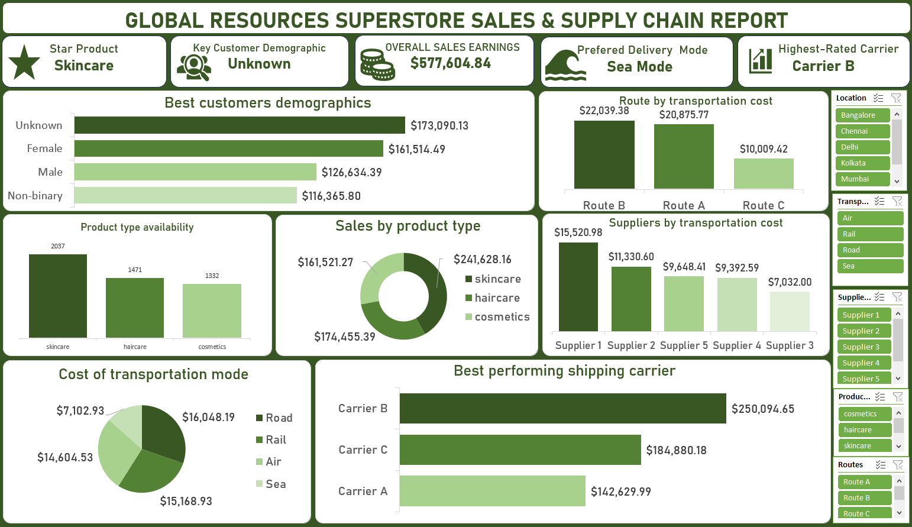

* Chart 1: Sales by Product type

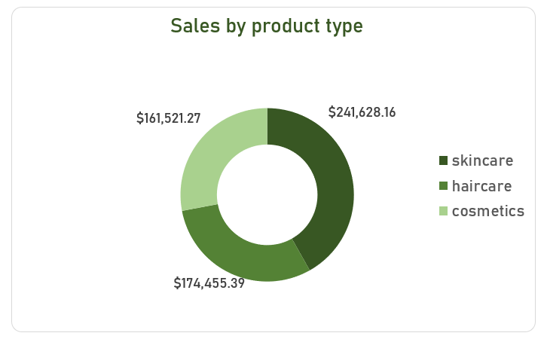 This pie chart is showing product types by sales generated.

The chart clearly shows the leading product type as skincare (with sales revenue as $241,628.16), with Haircare product type taking the second position ($174,455.39) and Cosmetics ($161,521.27). The business tracking of the sales contribution of the different product types is a strategy to increase revenue and profitability by maximizing the sales.

Chart 2: Route by Transportation cost

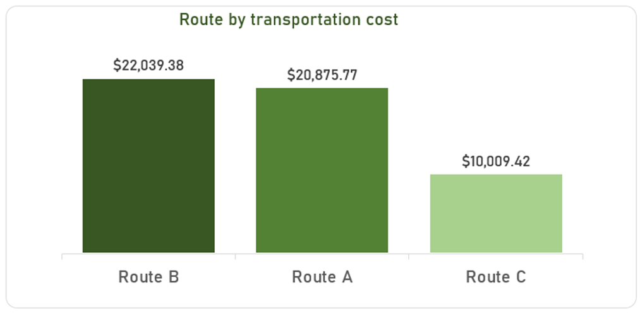

This analysis showcases the contribution made by different routes in support of revenue through differentiation of transportation cost. In optimization of routes for better, cost-effective and fastest delivery of products transportation cost is one of the factors to be considered. Hence, this chart spells out the top route to be considered by suppliers and supply chain managers. Route C ($10,009.42) was the preferred route with the lowest transportation cost. In engaging suppliers, this should be considered by the business.

Chart 3: Best Customer Demographics

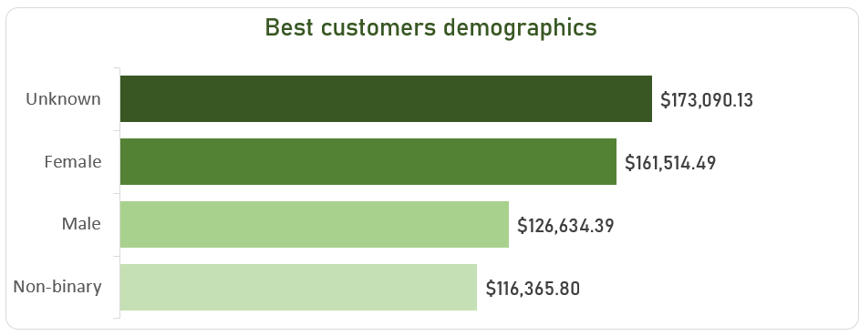

The customer demographics analysis clearly shows the leading customer category as Unknown with a grossing sale of $173,090.13 and non-binary ($116,365.80) was the lowest performing by their purchasing power. Identification of this category would help the business to target this customer base to increase sales while conducting promotional and innovative strategies to increase sales performance of the other categories.

Chart 4: Best Performing Shipping Carriers

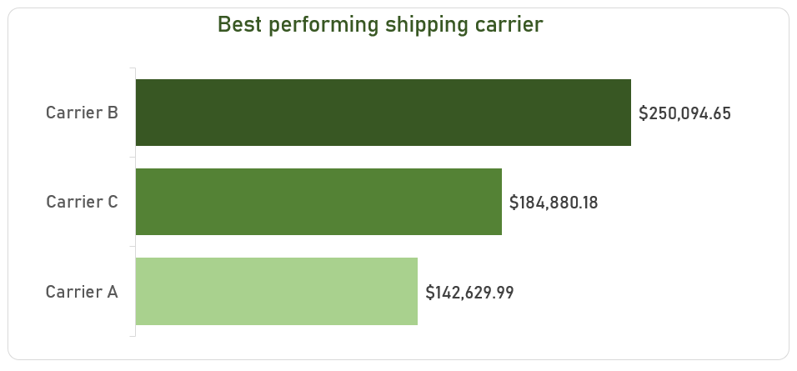

The analysis of the best shipping carrier serves to identify the shipping carrier that led the chart in terms of revenue generated and possibly the highest quantities of stock shipped. Carrier B ($250,094.65) is the best shipping carrier and should be utilized more by the business. Maximized Carrier B to cover the different customers categories thereby replicating its success with Unknown customers with the other categories.

Chart 5: Cost of Transportation Mode

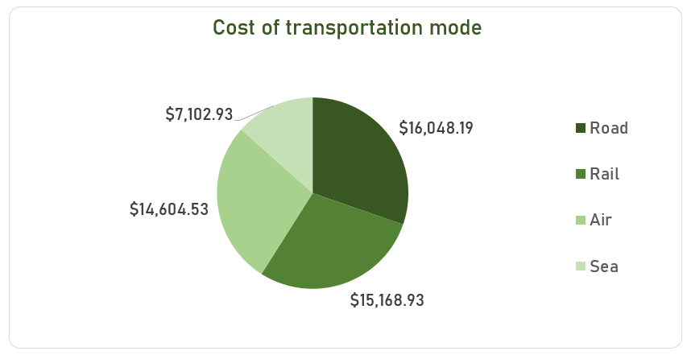

A major part of the supply chain is the transportation mode utilized to conduct delivery and long haul of commodities between central warehouse and distribution points. In this analysis, the insight sorted was the contribution of transportation mode based on their cost. Sea mode accounted for the cheapest mode of transportation with a cost of $7,102.93 and Road mode incurred the highest cost of $16,048.19.

Chart 6: Products Availability

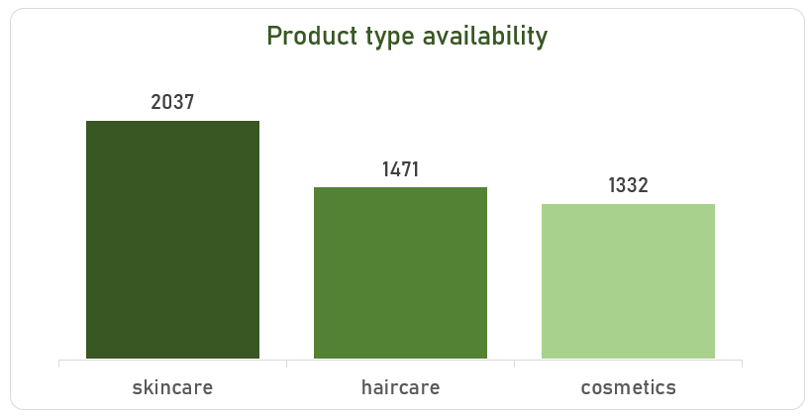

This column chart shows the availability of the products of this superstore in term of the stock level, Skincare products which is the top ranked products based on sales revenue was also the product with the highest available stock level of 2037 unit of the product.

Chart 7: Supplier by transportation cost

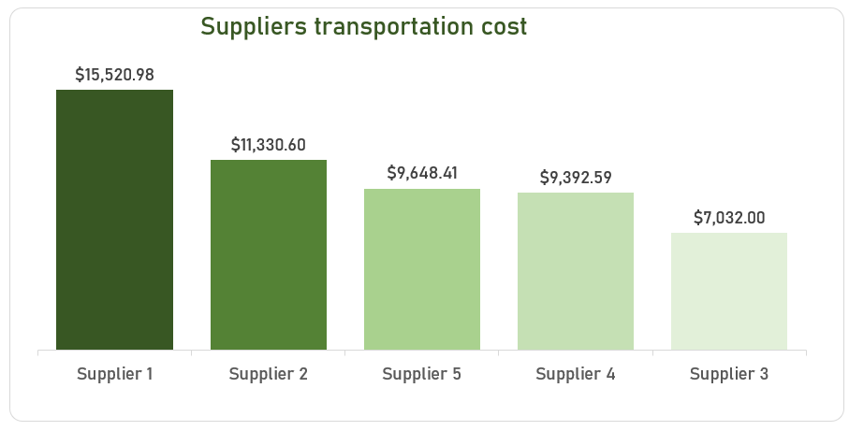

Based on incurred transportation cost, supplier 3 is the top supplier with the lowest transportation cost of $7,032.00 and supplier 1 ($15,520.98). Strategic decision would be to increase the volume of procurement assigned to supplier 3, as this will help reduce cost of transportation and increase profitability.

# 8. Observations and Recommendations

## Observations

* Route A has a total transportation cost of $20,875.77, this is the highest transportation cost when compared to the other two routes (B & C). Supplier 3 (best performing supplier) had the lowest cost of $1,955.50 along this route. The location Delhi has the lowest transportation cost by location of $6,790.71
* Route C had the lowest transportation cost of $10,009.42 and it was the most cost-effective route. This route was the best used by the Unknown customer category with $63,066.50 and skincare was the highest selling product type by this route amounting to $85,516.36
* Skincare leads the market that is a strong indication of preferred customers demand for this product category when compared to the other product.
* Customer segmentation data is incomplete, with a large portion classified as Unknown limiting targeted marketing opportunities.
* Carrier B is the most efficient shipping partner, handling the highest volume and potentially providing the best service quality.
* Sea mode is the preferred shipping method, balancing cost-effectiveness with logistical efficiency
* Supplier 1 incurs the highest transportation cost which may impact profitability.
* Delhi offers the lowest transportation cost, making it a potential hub for distribution.

## Recommendations

* The business should enhance customer data collection, implement a better tracking and analysis system to identify key customers demographics and improve targeted marketing efforts. This can help optimize promotion and innovative strategies to boost customers' purchase and revenue.
* It is proposed that the organization could shift procurement from high-cost suppliers (Supplier 1) to cost-efficient alternatives (Supplier 3). This process will help optimize the supplier selection process.
* By maximizing partnership with Carrier B due to its high efficiency and superior performance, the business can leverage Carrier B for logistics optimization.
* There is a need to replace road transportation with a less expensive and efficient alternative. Reliance on cost-efficient alternatives like sea and air mode could lead to increased revenue.
* Expand skincare product category through investment in product development, marketing and availability, this will help capitalize on their high demand and sales.
* Delhi could act as a hub for distribution due to its low transportation cost, creating a central distribution hub in this city will help minimize transportation costs and increase profit.

# Conclusion

The Global Resources Superstore demonstrates strong sales performance, especially in the skincare product category. However, identified inefficiencies in supply chain cost and transportation routes present opportunities for improvement. The business would need to implement strategies from derived insights to gain increased sales and revenue, market competitiveness, supply chain efficiencies and optimization of transportation modes and routes.

The business can also perform better by refining customer segmentation, optimizing supplier selection, and reducing logistics expenses. If these insights are carefully implemented, the business can further enhance profitability and operational efficiency.